HB 852 Briefing—“Streamline the Good Samaritan Law”

US Government Accountability Office Study of Good Samaritans laws, March 2021
https://www.gao.gov/products/gao-21-248

“GAO reviewed 17 studies that provide potential insights into the effectiveness of Good Samaritan laws in reducing overdose deaths or the factors that may contribute to a law’s effectiveness. GAO found that, despite some limitations, the findings collectively suggest a pattern of lower rates of opioid-related overdose deaths among states that have enacted Good Samaritan laws, both compared to death rates prior to a law’s enactment and death rates in states without such laws. In addition, studies found an increased likelihood of individuals calling 911 if they are aware of the laws. However, findings also suggest that awareness of Good Samaritan laws may vary substantially across jurisdictions among both law enforcement officers and the public, which could affect their willingness to call 911.”

Attachment 1 (page 18 of the US GAO study) shows that North Carolina is one of only six states that protects only from prosecution. The majority protect for arrest, charge, and prosecution.

CDC, Evidence-Based Strategies for Preventing Opioid Overdose: What’s Working, 2018
https://www.cdc.gov/drugoverdose/pdf/pubs/2018-evidence-based-strategies.pdf

Lists Good Samaritan laws as one of the ten most effective strategies to prevent overdose.
“Good Samaritan Laws are most effective when: Immunity is extended to all bystanders on the scene, not only to the individual in crisis and the individual who called 911.” (see Attachment 2)

NC Injury & Violence Prevention Branch Core Overdose Data Slides, November 2020
https://www.injuryfreenc.ncdhhs.gov/DataSurveillance/Poisoning.htm

See Attachment 3 for a chart of the types of drugs involved in NC overdose deaths for the past 20 years. (One death can be represented in multiple drug categories in this graph if multiple drugs were found to have contributed to the person's overdose.)

Around 2014, the drug supply began to be tainted with fentanyl (labeled as "other synthetic narcotic" in this graph), and that is why the heroin deaths started to skyrocket. Cocaine deaths and psychostimulant deaths (which include methamphetamine deaths) have shown a large uptick as well, as these drugs are often tainted with fentanyl too.

Possession of fentanyl receives no protection under our current Good Samaritan law, ignoring the #1 reason a person would need to call 911 for an overdose. Possession of methamphetamine also receives no protection under our current law, even though methamphetamine overdose is on the rise.
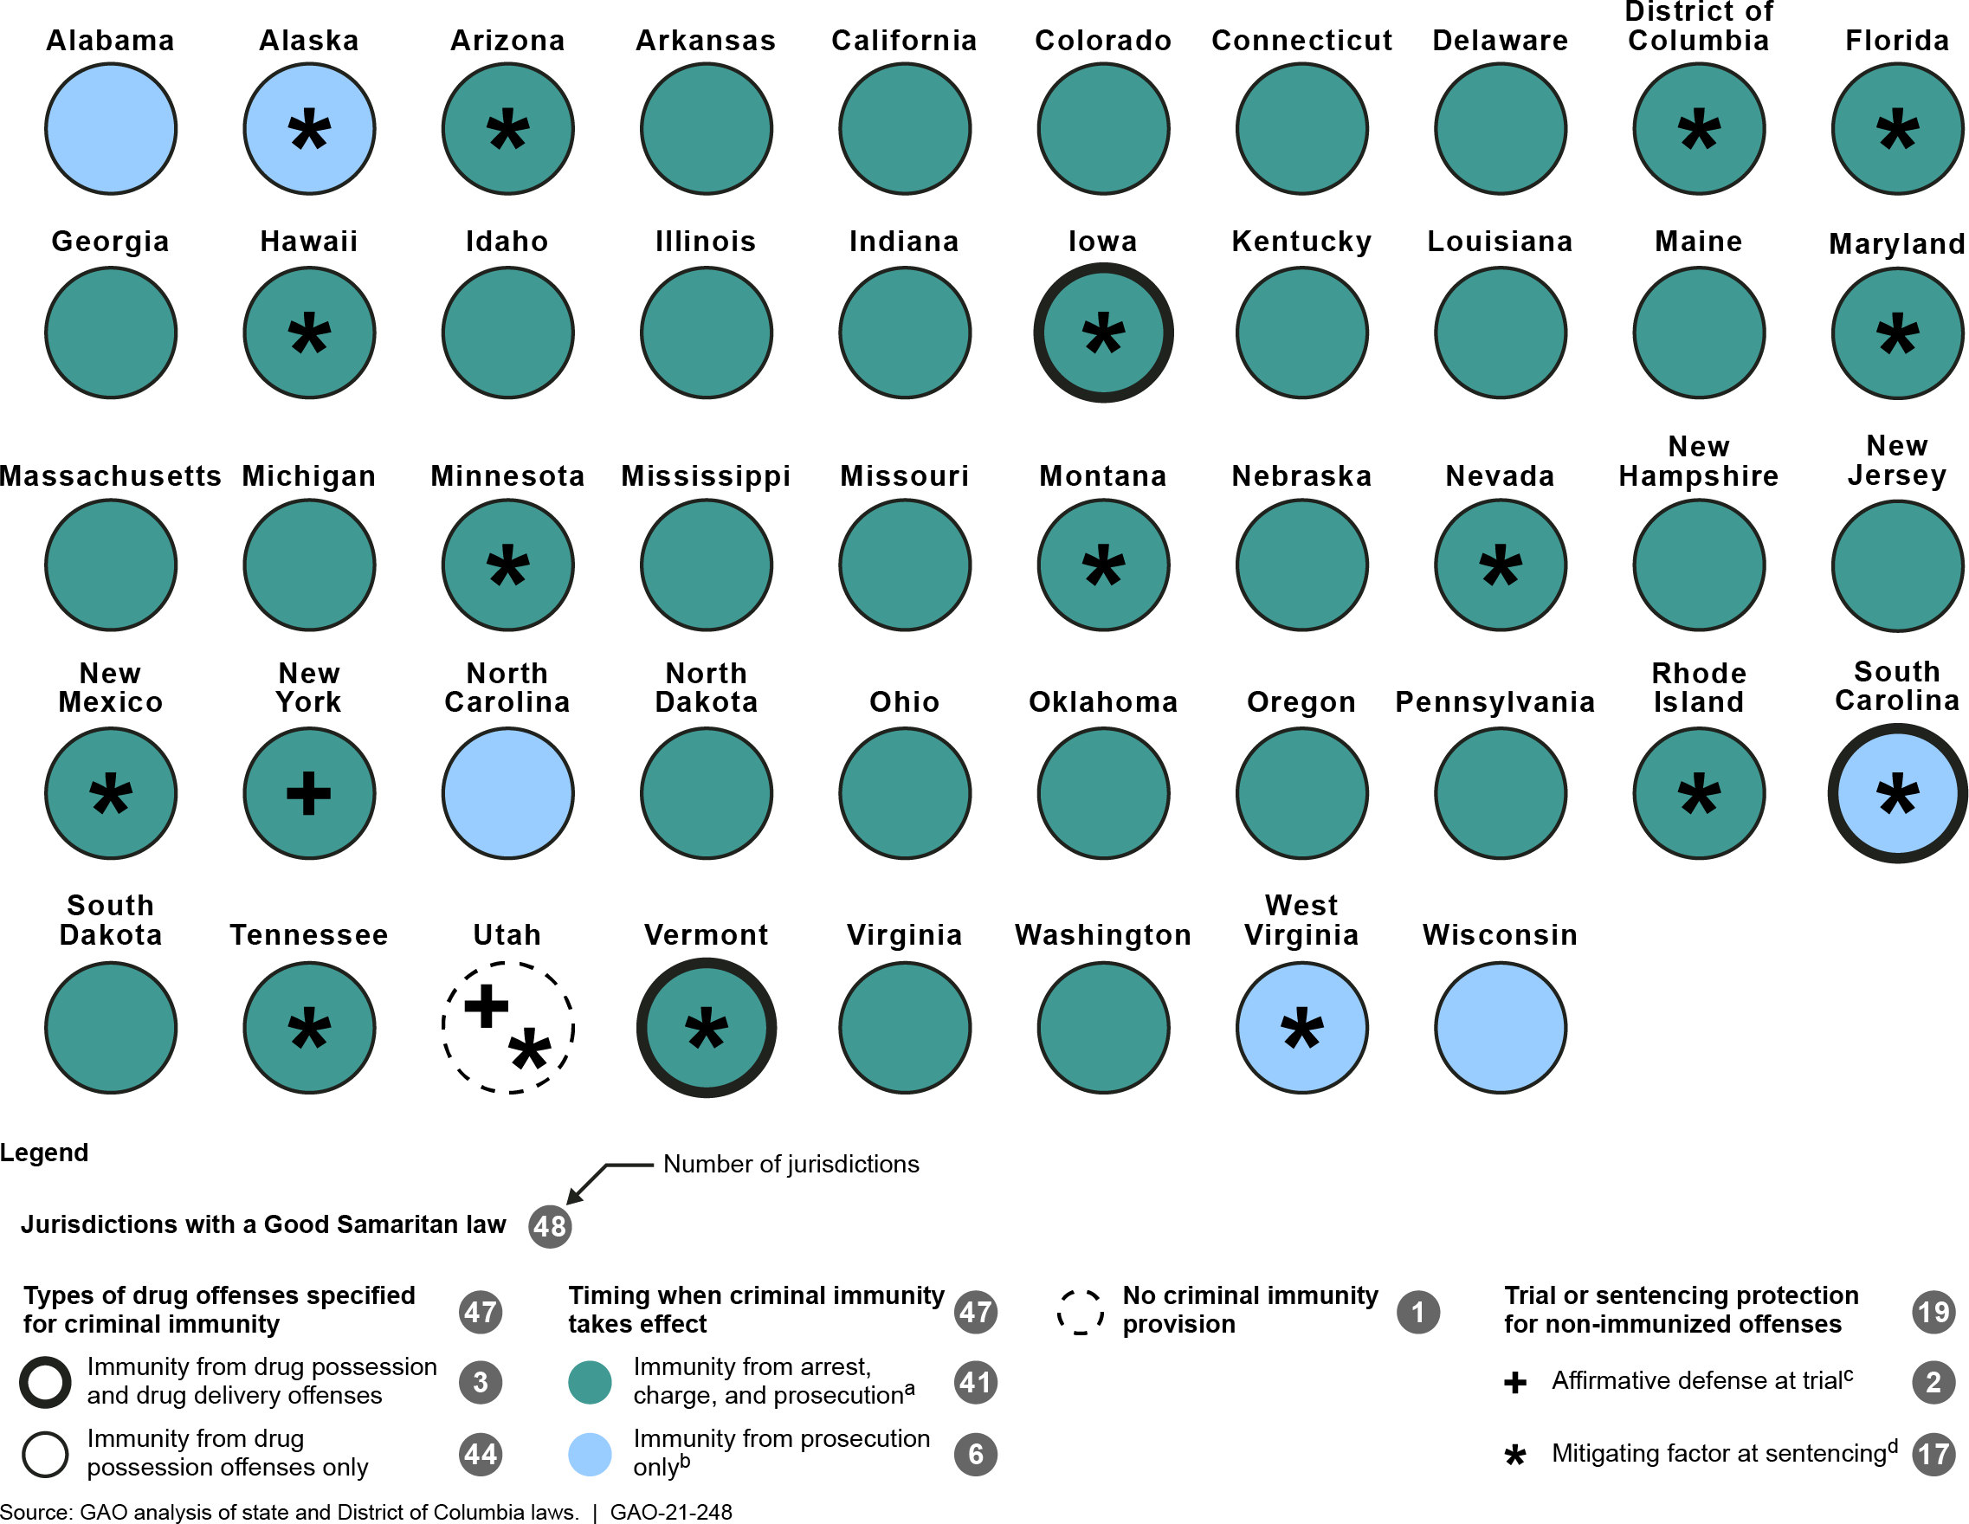
Attachment 1

Figure 3: Selected Characteristics of Jurisdictions’ Good Samaritan Laws

Notes: Kansas, Texas and Wyoming are not included in this figure because they do not have a Good Samaritan law specific to a drug overdose. Our analysis is based on laws we researched in May 2020 using online legal databases. However, in November 2020, we updated our analysis of Virginia’s law to reflect a July 2020 amendment, which we identified based on our review of the Legislative Analysis and Public Policy Association’s August 2020 report on Good Samaritan laws.
ªImmunity from arrest, charge, and prosecution prevents an individual from being arrested and charged as a criminal defendant, thereby eliminating the possibility of being prosecuted.
^{b}Immunity from prosecution only does not prevent an individual from being arrested and charged as a criminal defendant but prevents prosecution by providing for the dismissal of charges before trial.

Attachment 2
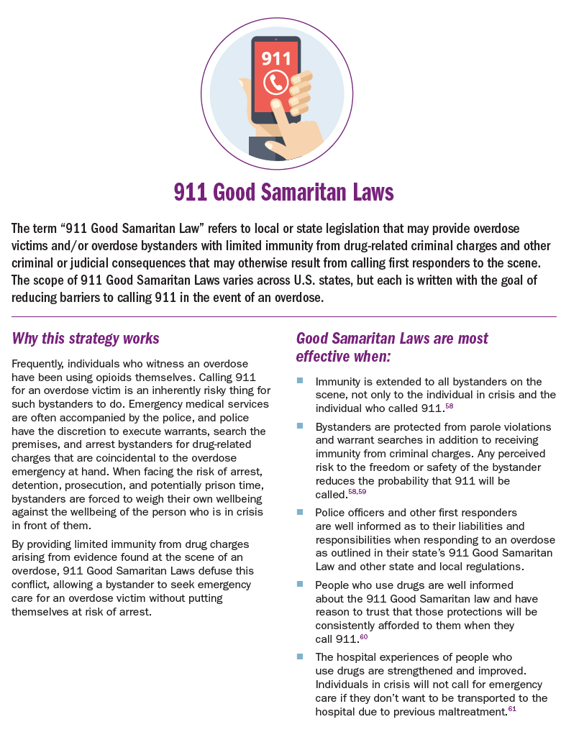

Attachment 3
